Sight reduction of the navigation triangle. An example using the Bygrave and Fuller Cylindrical Slide Rules. Francis Upchurch. 10/11/13
Introduction
Like all celnav enthusiasts, I enjoy finding my approximate position at sea using a sextant to measure various angles of the heavenly bodies, which , with a little bit of maths and accurate time, can miraculously fix my position to within a mile or two (or five). Free apps on my phone can do the maths quickly and perfectly, but I also enjoy the non electronic, organic feel and interaction of the slide rule. Obsolete, but fun, just like the sextant. For similar lost (and found?) souls, here is one example I prepared earlier, using the Fuller and Bygrave cylindrical slide rules.
Fuller Cylindrical Slide Rule
I have no specialist knowledge, very little maths and just like slide rules as I like sextants. My 1960s Thornton school- boy linear rule has a 10 inch scale. It is not accurate enough ( 2-3 decimal places) for navigation. The Fuller has a spiral scale up 42 feet long and therefore has accuracy from to 5-7 decimal places. It basically gives similar results to a modern calculator, but takes a little longer. I was privileged to inherit my grandfather’s Fuller 1, vintage 1920s, in perfect condition despite regular use (engineer). Too precious for the sea, and without trig functions, I built a Fuller 2 replica (with sine functions), courtesy the wonderful authentic, computer generated scales from Wayne Harrison. (see his slide rule Google site and nwharrison@sympatico.ca)
Replica Fuller 2, above Granddad’s original Fuller 1 circa 1920s
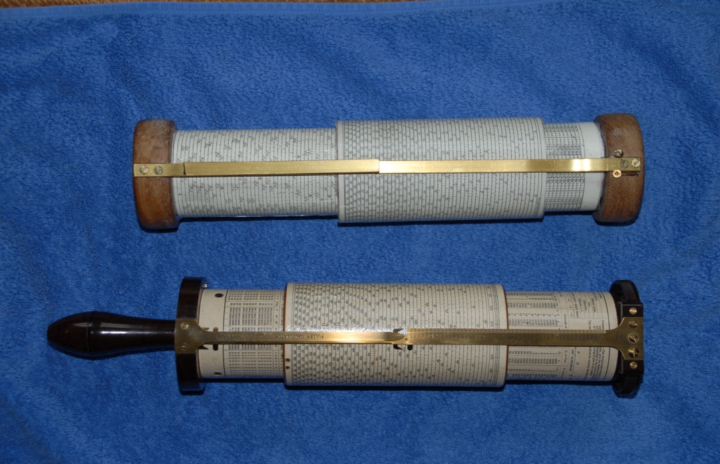
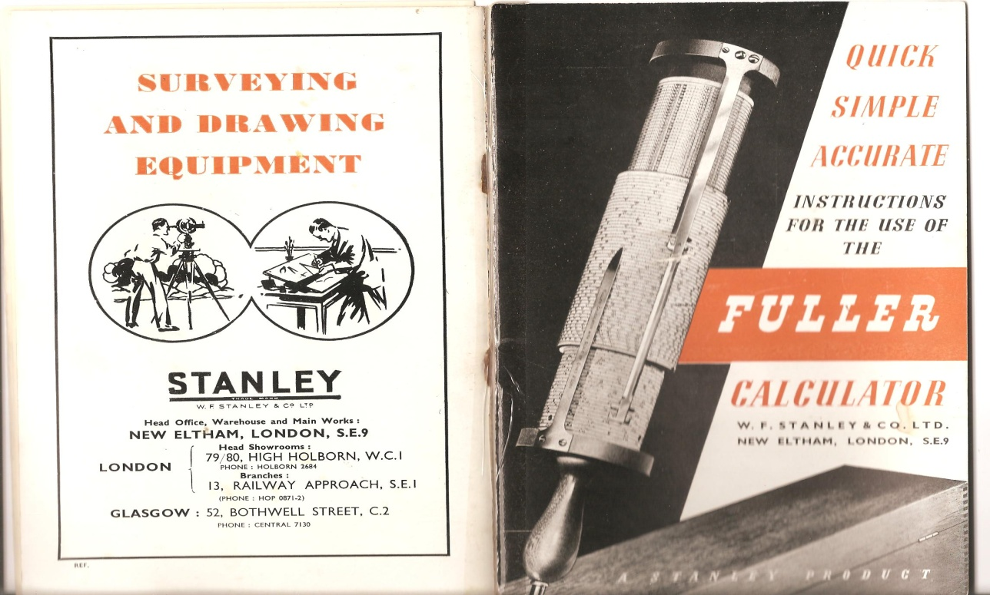
Cover from original manual from the Fuller 1.
The details of construction will follow in a separate paper in the near future. Details on request.
Fuller 2
The Fuller 2 has the same 42 feet scales of the type 1, but has additional sine and log scales. For cosines I have to subtract from 90˚ and use the sine scale.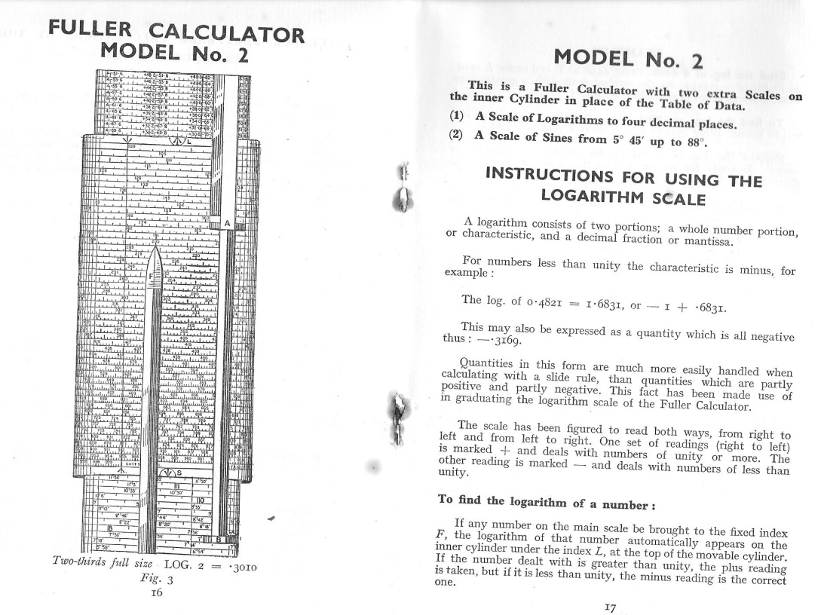
The method for using the sine scales is shown in the manual instructions below.
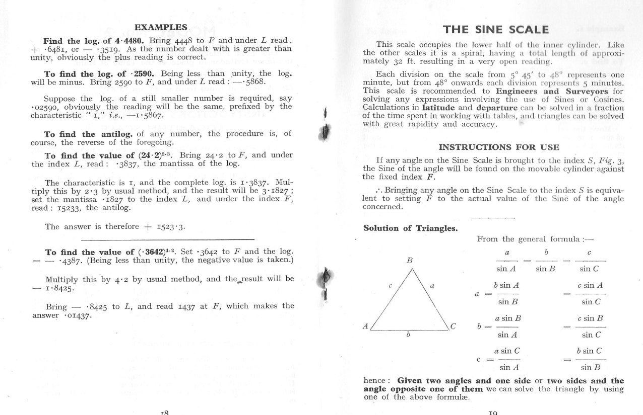

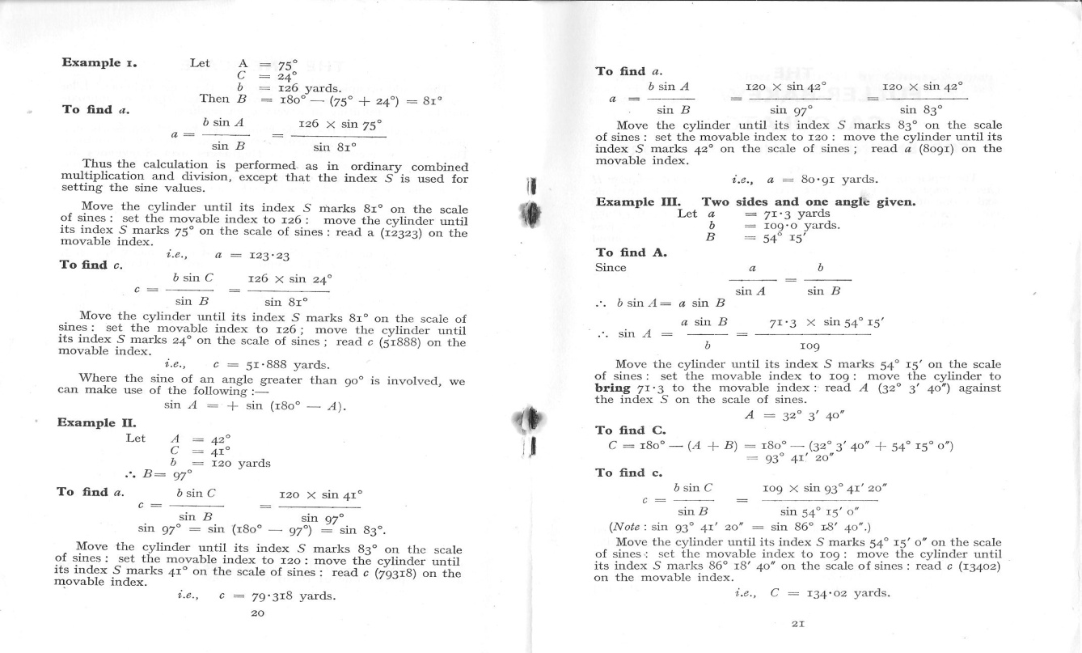
Example of a sight reduction
GHA 304˚ 22.6’
Dec 22˚ 59.5’N
LHA 298˚ 49.8’
LAT 50˚ 06’.8 N
Hc (computer) 35˚ 45.6’
Az (computer ) 96˚

Formulas
Sin Alt(Hc) = (cos LHA x cos Lat x cos Dec) +/- (sin Lat x sin Dec.)
Sin Az =sin LHA(cos Dec/cos alt).
Fuller 2 worksheet.
- Convert cosines to sines ;
Cos LHA 298˚ 49.8’= sine 28˚49’ 48’’
Cos 50˚ 06.8’= sine 39˚ 53’.
Cos 22˚ 59.5’N= sine 67˚
- Rotate outer cylinder so lower curser S at 28˚ 49’48’’ (read 0.4822 at curser F)
- Move curser A to 1 on outer cylinder
- Move S to 39˚ 53’ on sine scale. (read 0.64122 at F)
- Move 0.64122 to Curser B
- Move S to 76˚ (read 0.9205 at F)
- Move 0.9205 to B
- Read 0.2846 at F make note of this result
- Move S to 50˚ 6’ 48’’, read 0.7673 at F
- Move curser A to 1
- Move S to 22˚ 59’ 30’’ read 0.3905 at F
- Move 0.3905 to B
- Read 0.2997 at F
- Add the 2 parts. Ie 0.2846+0.2997= 0.5843.= sin Hc
- Set 0.5843 at F
- Read 35˚ 45.2’ on sine scale. = Hc
A similar process is required to find Az. It is actually quicker to do than explain, is probably still faster than tables (just). The Fuller is bulky, with delicate brass cursers and not ideal aboard a small, wet, pitching and rolling vessel. I therefore usually prefer to use the Bygrave.
The Bygrave (AML Position line rule)
This was invented by Capt Bygrave, RAF in the early 1920s and produced in small numbers by the Air Ministry Laboratory. It is smaller than the Fuller ( 24 ft scales) and uses different log and trig scales to reduce the triangle by a different formula. Gary LaPook and others have described this in detail in Navlist archives. (see also the comprehensive paper by Ronald WM van Riet 2008). It is designed to reduce the navigation triangle and is not therefore a “general use “slide rule like the Fuller.
I was lucky to find a relatively cheap, rare and perfect original on ebay and made a prototype copy, with help and scales from Gary LaPook. After making the Fuller 2 replica, I then produced my Bygrave replica , using scales donated by Wayne Harrison. They are all equally accurate. So it is just the “look and feel” I was after. (My slide rule thing is largely emotional and not logical.)
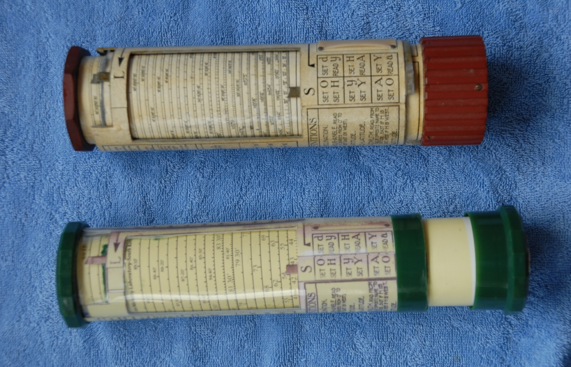
Original Bygrave 11A above first copy (Scales from Gary LaPook)
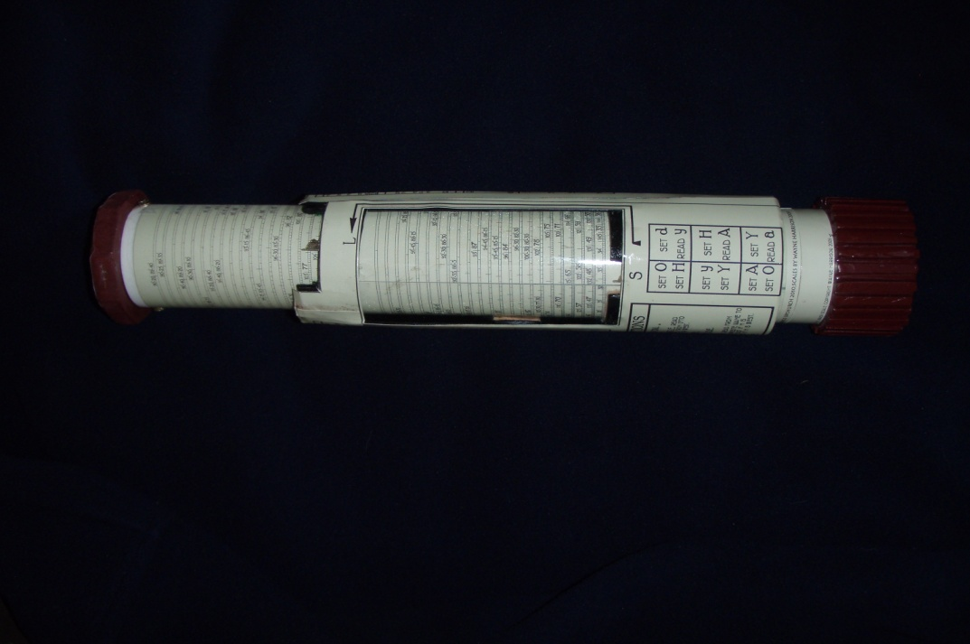
Bygrave Replica (scales from Wayne Harrison)
The Bygrave sight reduction process.
The instructions are printed on the curser and cylinders.
- Find “H”, or hour angle, rules depending on size of LHA. LHA >270 therefore =( 360˚-LHA )= 360˚ -298˚ 49.8’ =61˚ 10.2’
- Find co-latitude= 90˚ - 50˚ 06.8’ =39˚ 53.2’
- Set S (cos scale) to 0 , set inner (co-tan) scale (L) to Dec (22˚ 59.5’)
- Set S to H (61˚ 10.2’) read “y” = 41˚ 19’
- Set S to y (41˚ 19’), set H on L
- Set Y (Y=co-lat +y,) = 81˚ 12’
- Read Az on L=83˚ 36’, Zn according to rules = 180˚ - 83˚ 36’ =96˚
- Set S to Az (83˚ 36’), set Y (81˚ 12’) to L
- Set S to 0, read Hc at L = 35˚ 45.5’ (can be read to 0.5’ at this part of the scale.)
With practice, I tend to get both Hc and Zn to within 1’ and in half the time it takes me to do Hc alone with the Fuller and only slightly more than with a calculator. You have to work out H, co-latitude and Y and obey the various rules for LHA and Az printed on the rule. Otherwise, there are less moves and virtually no “writing down “of intermediate results. So the Bygrave is half the size of the Fuller, much easier and quicker to use and generally accurate to within 1’. I can see why Chichester used one for his solo flights during which he had to make multiple calculations while flying his open cockpit biplane . The main issue is the regular
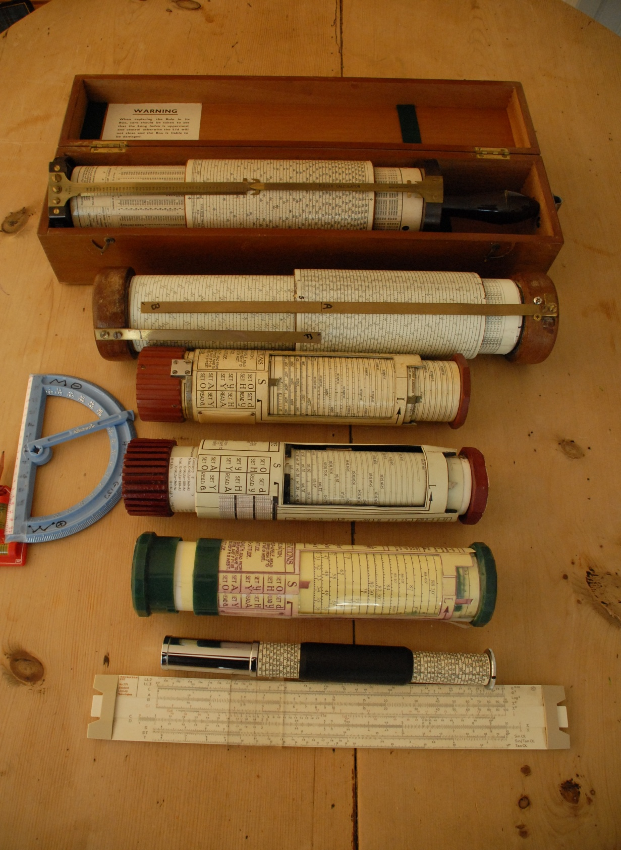
My slide rule collection. From top: Grandad’s Fuller 1, homemade replica Fuller 2 (Wayne Harrison scales), original Bygrave 11A circa late 1920s, providence unknown (no serial number) but perfect working condition. Homemade replica Bygrave 11A,(scales Wayne Harrison), first homemade Bygrave (Gary LaPook scales). Original Otis King circa 1960s. ( 4 feet scales, better than linear but not good enough for navigation).
My Thornton 10 ‘school- boy slide rule from 1960s. The beginning of a passion. The blue plastic protractor is not a slide rule, but my cheap nocturnal for measuring Polaris correction. (details on request. It works!)

servicing of the felt friction pads for perfect smooth movement without any possibility of “slippage” during operation. This could ruin your day if looking for a tiny island in the Tasman Sea on a solo flight. (Do read Chichester on this. Unbelievable. Do not try it at home.)
Conclusions
Cylindrical slide rules, with very long, spiral scales, are accurate enough for conventional navigation triangle calculations. The Bygrave is the quickest and easiest to use and closest to the modern calculator. The Fuller is the closest to calculators with respect to accuracy, but is very big and cumbersome, not practical on a small boat and slow. I am working on a smaller version. Watch this space.

